A Project Report

On

**Phishing URL Detection Using Machine Learning**

# Submitted to

# DELHI TECHNICAL CAMPUS

# (Affiliated Guru Gobind Singh Indraprastha University, New Delhi)

# Greater Noida

# 

in partial fulfillment of the requirements for the award of the degree of

Bachelor of Technology

By

**Jatin Chopra (35618011621)**

**Harshvardhan Singh (35518011621)**

under the guidance of

**Ms. Megha Kumar(Assistant Professor)**

**Dr. Priyanka Dadhich(Associate Professor)**

Computer Science and Engineering

DELHI TECHNICAL CAMPUS

GREATER NOIDA (U.P.)

January 2023

**DECLARATION BY THE STUDENT**

We, Jatin Chopra (35618011621) and Harshvardhan Singh(35518011621), student of B.Tech(Artificial Intelligence and Machine Learning) hereby declare that the project titled “Chatting Application using JAVA” which is submitted by me to Department of Computer Science and Engineering, DELHI TECHNICAL CAMPUS, Noida, in partial fulfillment of requirement for the award of the degree of Bachelor of Technology in Artificial Intelligence and Machine Learning , has not been previously formed the basis for the award of any degree, diploma or other similar title or recognition.

The Author attests that permission has been obtained for the use of any copy righted material appearing in the Dissertation / Project report other than brief excerpts requiring only proper acknowledgement in scholarly writing and all such use is acknowledged.

Signature

Greater Noida

Date Jatin Chopra (35618011621)

Harshvardhan Singh(35518011621)

**CERTIFICATE OF ORIGINALITY**

On the basis of declaration submitted by Jatin Chopra and Harshvardhan Singh, student of B.Tech, I hereby certify that the project titled “Chatting Application” which is submitted to, DELHI TECHNICAL CAMPUS, Noida, in partial fulfillment of the requirement for the award of the degree of Bachelor of Technology in Artificial Intelligence and Machine Learning , is an original contribution with existing knowledge and faithful record of work carried out by him/them under my guidance and supervision.

To the best of my knowledge this work has not been submitted in part or full for any Degree or Diploma to this University or elsewhere.

Date Ms. Megha Kumar

Dr. Priyanka Dadhich

**Computer Science and Engineering**

DELHI TECHNICAL CAMPUS, Greater Noida

**Abstract**

Teleconferencing or chatting refers to any kind of communication that offers a real-time transmission of messages from sender to the receiver. Chatting is a method of using technology to bring people and ideas together despite the geographical barriers. The technology to provide the chatting facility has been available for years, but the acceptance is quite recent. Analysis of chatting provides an overview of the technologies used, available features, functions, system of the architecture of the application, the structure of database of an Instant Messaging application: IChat(IC). The objective of IC application is to facilitate text messaging, group chatting option, data transfer without size restriction which is commonly seen in most of the messaging applications.

**ACKNOWLEDGEMENT**

I would like to express my sincere gratitude to my project guide **“Ms. Megha Kumar and Dr. Priyanka Dadhich”** for giving me the opportunity to work on this topic. It would never be possible for us to take this project to this level without his innovative ideas and his relentless support and encouragement.

**Jatin Chopra**

**(35618011621)**

**Harshvardhan Singh**

**(35118011621)**

# CONSENT FORM

This is to certify that We, **Jatin Chopra** and **Harshvardhan Singh** , student of B.Tech in Artificial Intelligence and Machine Learning of 2021-2025 presently in the IV Semester at DELHI TECHNICAL CAMPUS, Greater Noida give my consent to include all my personal details for all accreditation purposes.

Place: Jatin Chopra

Date: Harshvardhan singh

**DECLARATION FORM (Health, Safety & Plagiarism)**

We, Jatin Chopra(35618011621) and Harshvardhan Singh(35118011621), student of B.Tech Artificial Intelligence and Machine Learning, batch 2021-2025, Institute / Department of Computer Science and Engineering, Delhi Technical Campus, GGSIP University, New Delhi, hereby declare that utmost care was take not to harm anyone either physically or emotionally. I/We have gone through project guidelines including plagiarism.

**Date: Jatin Chopra(35618011621)**

**Place: Harshvardhan Singh(35118011621)**

**LIST OF FIGURE**

|  |  |  |
| --- | --- | --- |
| **Figure No.** | **Figure Name** | **Page No.** |
| 1.1 | abcd | 2 |
| 1.2 | efgh | 4 |
| 1.3 |  |  |
| 2.1 |  |  |
| 2.2 |  |  |
| 2.3 |  |  |

**LIST OF TABLES**

|  |  |  |
| --- | --- | --- |
| **Table No.** | **Table Name** | **Page No.** |
| 1.1 | abcd | 2 |
| 1.2 | efgh | 4 |
| 1.3 |  |  |
| 2.1 |  |  |
| 2.2 |  |  |
| 2.3 |  |  |

**LIST OF SYMBOLS AND ABBREVIATION**

|  |  |  |
| --- | --- | --- |
| **S. No.** | **Symbols and Abbreviation** | **Page No.** |
| 1 |  | 2 |
| 2 |  | 4 |
| 3 |  |  |
| 4 |  |  |
| 5 |  |  |
| 6 |  |  |

# 

# DELHI TECHNICAL CAMPUS

# (Affiliated Guru Gobind Singh Indraprastha University, New Delhi)

# Greater Noida

**CONTENTS**

|  |  |
| --- | --- |
| **Candidate’s declaration** | i |
| **Certificate of originality** | ii |
| **Abstract** | iii |
| **Acknowledgement** | iv |
| **Consent Form** | v |
| **Declaration** | vi |
| **Contents** | vii |
| **List of Figures** | vii |
| **List of Tables** | ix |
| **List of Symbols and Abbreviation** | x |

|  |  |  |
| --- | --- | --- |
| **CHAPTER 1** | **INTRODUCTION** | **1 - 5** |
| 1.1 | Overview |  |
| 1.2 | Problem statement and significance |  |
| 1.3 | Objective of the project |  |
| 1.4 | Scope |  |
| 1.5 | Challenges |  |
| 1.6 | Overview of the report structure |  |
|  |  |  |
| **CHAPTER 2** | **LITERATURE REVIEW** | **6 - 9** |
| 2.1 | Overview of chatting application and their use |  |
| 2.2 | Literature Review |  |
| **Chapter 3** | **REQIREMENTS AND ANALYSIS** | **10 - 12** |
| 3.1 | Requirement Specification   |  | | --- | | 3.1.1 Software Requirements | | 3.1.2 Hardware Configuration Requirements | |  |
| 3.2 | Functional Requirements |  |
| 3.3 | Non-Functional Requirements |  |
|  |  |  |
| **Chapter 4** | **SYSTEM DESIGN** | **13 - 18** |
| 4.1 | System Architecture |  |
| 4.2 | Data Flow Diagrams |  |
| 4.3 | UML Activity Diagram |  |
| 4.4 | Summary |  |
| **Chapter 5** | **IMPLEMENTATION AND CODING** | **19 - 21** |
| 5.1 | Process involved in implementation |  |
| 5.2 | Classifiers |  |
|  |  |  |
| **Chapter 7** | **RESULTS AND DISCUSSION** |  |
| 7.1 | Experimental Analysis |  |
|  |  |  |
| 7.3 | Running Project Screenshot |  |
| **Chapter 8** | **CONCLUSION** |  |
| 8.1 | Conclusion |  |
| 8.2 | Future Scope |  |

|  |  |
| --- | --- |
| **REFERENCES** |  |
| **RESEARCH PAPER** |  |
| **PLAG REPORT OF THESIS AND RESEARCH PAPER** |  |

# CHAPTER – 1

# INTRODUCTION

Chatting Application is a desktop based application.

This client server chat application is based on java swing and used socket package. its simple and easy and require only core java knowledge. I have taken this program from internet and modified a little bit to make it simpler and more elegant.

This application/program is a good example of using java.io, java.net package to create a chat application. A beginner of java language, who is familiar with this packages can able, be beneficiate.

Chatting is a method of using technology to bring people and ideas “together” despite of the geographical barriers. The technology has been available for years but the acceptance it was quit recent. Our project is an example of a multiple client chat server.

It is made up of 2 applications the client application, which runs on the user’s Pc and server application, which runs on any Pc on the network. To start chatting client should get connected to server. We will focus on TCP and UDP socket connections which are a fundamental part of socket programming.

Keywords: sockets, client-server, Java network programming-socket functions, Multicasting etc.

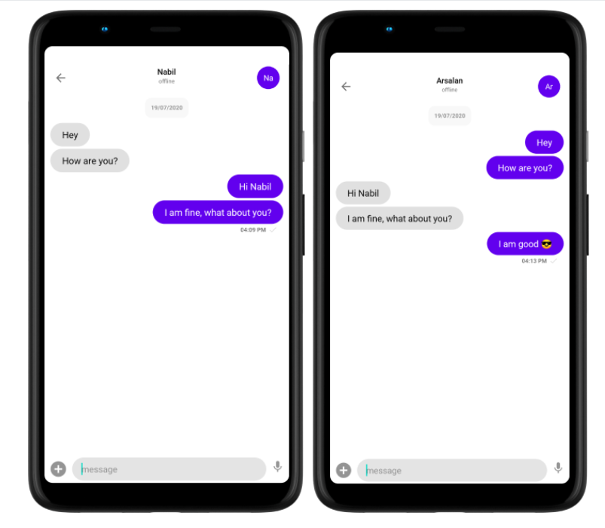

## Background and Motivation

Figure 1.1: Statistics Of Phishing Attacks Observed In Last Three Years.(Source: ThreatLabz 2023 Phishing Report) [2]

The rapid growth of online transactions, social media usage, and digital communication channels has created an environment ripe for phishing attacks. Cybercriminals exploit vulnerabilities in human psychology, technology, and system vulnerabilities to carry out these attacks. As a result, individuals and organizations face substantial financial losses, reputational damage, and compromised privacy due to falling victim to phishing attacks.

The escalating threat of phishing attacks and their far-reaching consequences necessitate effective countermeasures to detect and mitigate such threats. Traditional rule-based approaches and static blacklists have proven to be insufficient in keeping up with the dynamic and sophisticated nature of phishing attacks. Machine learning techniques offer promising solutions for detecting and combatting these attacks.

The motivation behind this project is to develop a robust and accurate phishing URL detection system using machine learning algorithms. By leveraging the power of machine learning, we aim to enhance the ability to identify and classify phishing URLs in real-time. This system can serve as a proactive defence mechanism to prevent users from accessing malicious websites and falling victim to phishing scams.

The primary objective is to design and implement a machine learning model that can analyse various features and patterns present in URLs to distinguish between legitimate and phishing URLs. By exploring and utilizing different machine learning algorithms, we seek to enhance the accuracy, efficiency, and scalability of the detection system. The successful implementation of such a system could significantly reduce the risks associated with phishing attacks and provide a safer online experience for users.

Overall, the background and motivation behind this project stem from the pressing need to address the rising threat of phishing attacks, protect users' sensitive information, and create a more secure digital environment. By leveraging the power of machine learning, we strive to contribute to the development of effective phishing detection mechanisms and bolster cybersecurity efforts.

## Problem statement and significance

The **problem statement** for a Chatting Application using Java could be framed as follows: Developing a Chatting Application that overcomes the challenges of real-time messaging, scalability, and user experience while ensuring security and efficient communication between users.

**Significance**:

## The importance of designing a Chatting Application in Java may be found in the following aspects:

## Real-time Communication: Chatting software allow users to communicate in real time, facilitating speedy and efficient information flow. With its networking and concurrency capability, Java is an ideal platform for constructing real-time messaging systems.

## Chatting programmes enhance cooperation among individuals or groups by allowing them to chat, exchange ideas, and work together remotely. Users may interact and converse successfully regardless of their geographical location by designing a Chatting Application in Java.

## Accessibility and Convenience: Java-based Chatting Applications may be accessible via a variety of devices, including PCs, laptops, smartphones, and tablets, allowing users to stay connected and join in discussions at any time and from any location.

## Security and Privacy: It is critical in Chatting Applications to ensure the security and privacy of user data. Java includes strong security features and libraries that may be used to construct encryption, authentication processes, and secure data transport, therefore safeguarding users' personal information.

## Scalability and speed are critical since Chatting Applications strive to service a high number of concurrent users. Java's scalability capabilities, together with its ability to manage multithreading and asynchronous communication, allow it to accommodate a high rate of chat interactions while still providing a responsive user experience.

1. Extensibility and Customization: Because of Java's flexibility and huge ecosystem of libraries and frameworks, developers may modify the Chatting Application's features. They can include capabilities such as file sharing, phone and video chatting, group chats, and integration.

## Objective of the project

The aim of this project is to express how we can implement a simple chat application between a server and a client? The application is a desktop based application and is implemented using Swing and awt. The project is developed in Java SE language executed on a single stand-alone java across a network using loop back address concept.

Application consists of two programs:

Server

Client

### **Server**

The server module of the application waits for the client to connect to it. Then if connection is granted a client interacts communicates and connects to the server, it can mutually communicate with the server. The duty of the server is to let clients exchange the messages.

### **Client**

The client module is the one that utilizer sends requests to the server. Utilizer utilizes the client as the means to connect to the server. Once he establishes the connection, he can communicate to the connected server.

.

## Scope

This project can be mainly divided into two modules:

1. Server
2. Client

This project is mainly depended on client/server model. The client requests the server and server responses by granting the clients request. The proposed system should provide both of the above features along with the followed ones:

Server

A server is a computer program that provides services to other computer programs (and their users) in the same or other computers. The computer that a server program runs in is also frequently referred to as a server. That machine may be a dedicated server or used for other purposes as well. Example Server, Database, Dedicated, Fileserver, Proxy Server, Web Server. The server is always waiting for client’s requests. The client come and go down but the server remains the same.

A server application normally listens to a specific port waiting for connection requests from a client. When a connection request arrives, the client and the server establish a dedicated connection over which they can communicate. During the connection process, the client is assigned a local port number, and binds a socket to it. The client talks to the server by writing to the socket and gets information from the server by reading from it. Similarly, the server gets a new local port number (it needs a new port number so that it can continue to listen for connection requests on the original port). The server also binds a socket to its local port and communicates with the client by reading from and writing to it. The client and the server must agree on a protocol that is, they must agree on the language of the information transferred back and forth through the socket. Normally, a server runs on a specific computer and has a socket that is bound to a specific port number. The server just waits, listening to the socket for a client to make a connection request.

### 1. THE SERVER SCREEN

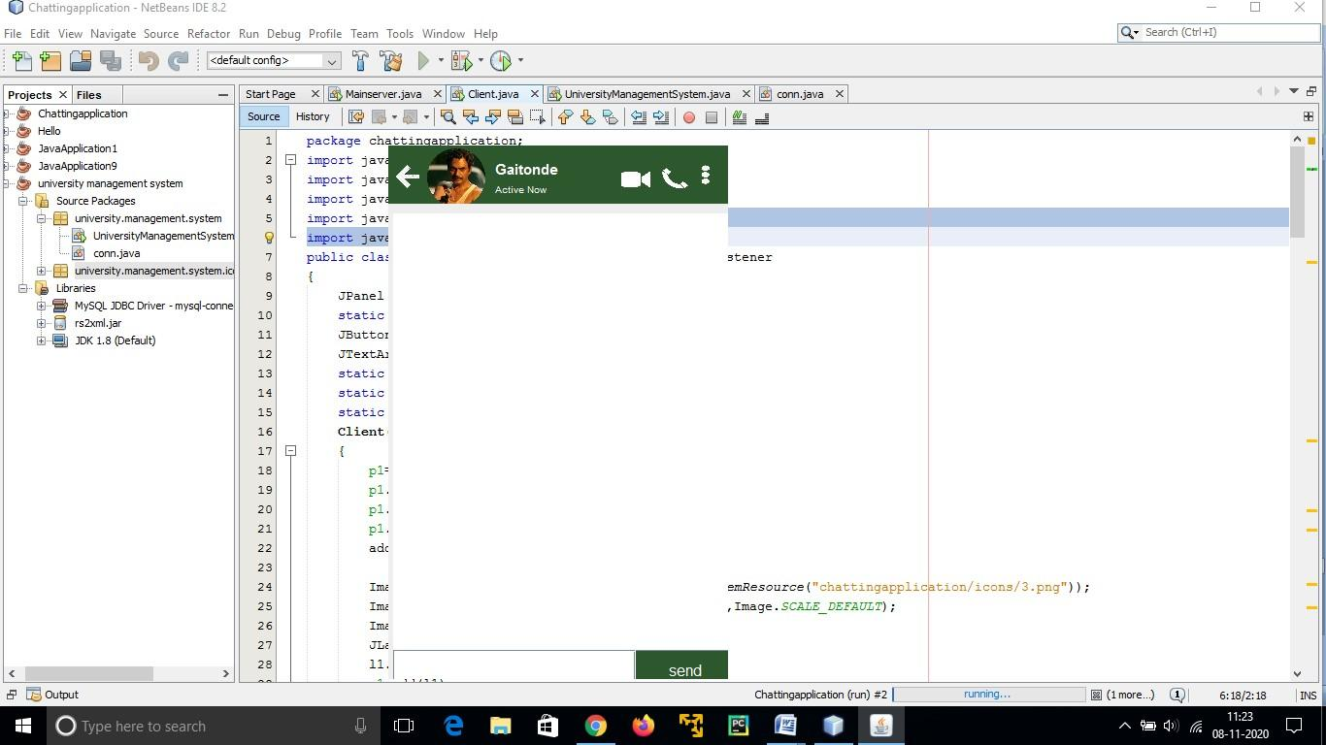

## Client

On the client site the client knows the hostname of the machine on which the server is running and the port number on which the server is listening.

To make a connection request, the client tries to rendezvous with the server on the server's machine and port. The client also needs to identify itself to the server so it binds to a local port number that it will use during this connection. This is usually assigned by the system.

### The model used for this project is the single server –

Single client models.

The following specifications must be implemented:

1. The server and client are two separate programs.

1. THE CLIENT SCREEN

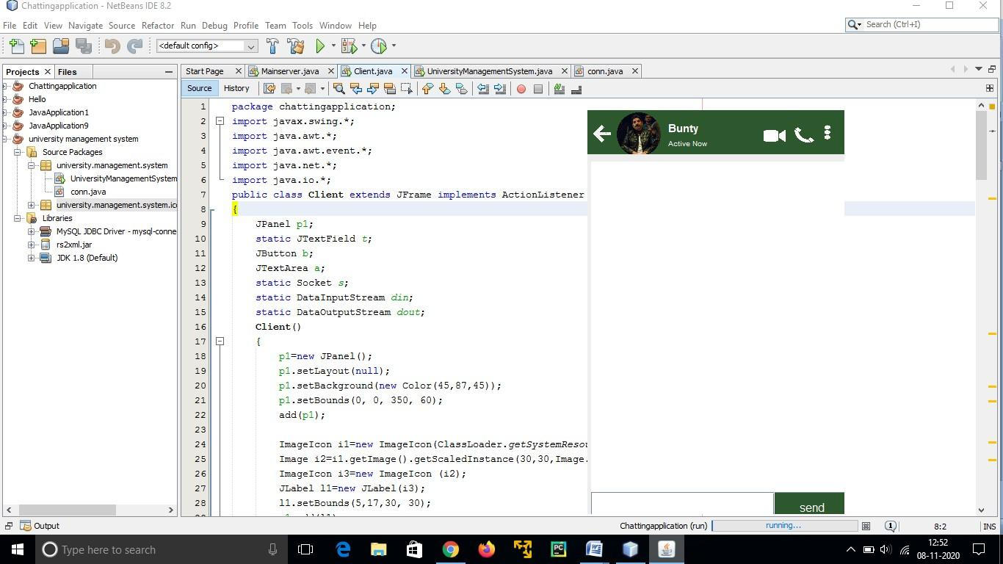

1. THE CLIENT SERVER SCREEN

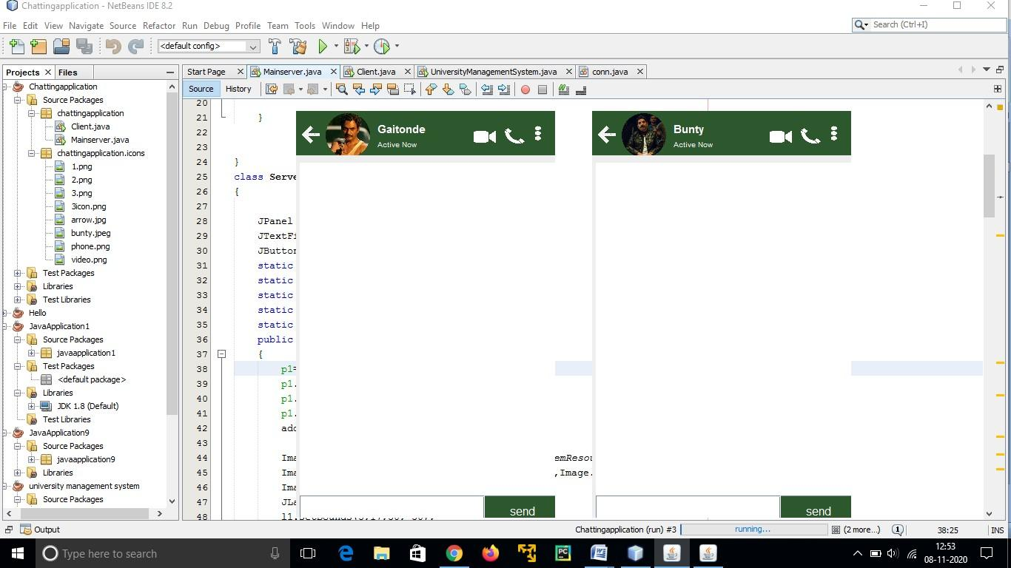

# CHAPTER – 2

# LITERATURE REVIEW

## 2.1 Chatting Application and its various Applications

## A chatting application is a software platform that allows people to connect in real time using text, audio, or video messaging. These applications have grown in popularity in recent years, revolutionising the way individuals connect and communicate with one another. Here are some of the most popular uses and benefits of messaging apps:

## Chatting software enable people to communicate quick text messages to one another in a simple manner. It enables speedy and effective communication, making real-time chats possible regardless of the distance between users.

## Many messaging apps provide group chats, allowing numerous users to engage in a single session. This is especially helpful for coordinating events, discussing projects, or simply keeping in contact.

Chatting programmes frequently offer the exchange of many types of multimedia material, such as images, videos, documents, and links. This feature enables users to effortlessly share files and media with others, hence improving the overall communication experience.

Voice and video calls: Many messaging apps have voice and video calling features, allowing users to hold face-to-face or voice interactions with others. This is particularly useful for long-distance communication or when a more personalised touch is required.

Emojis and stickers: Chatting apps frequently feature a variety of emojis, stickers, and GIFs for users to incorporate in their conversations. These graphic aspects make talks more enjoyable and expressive, allowing users to communicate emotions and sentiments more effectively.

Integration with other services and platforms: Some talking apps interface with other services and platforms, such as social network accounts, email accounts, or productivity tools. Users can utilise this connection to get new services or contribute material from other platforms right from the chat application.

Chatting programmes are commonly utilised in professional contexts for team collaboration and corporate communication. They include capabilities like as file sharing, project management integrations, and conversation history, making them useful tools for remote teams or businesses with numerous locations.

Customer service: Many firms use talking apps to give customer service and help. Users may connect with customer support personnel in real time and receive rapid replies to their questions or concerns.

Language translation: Language translation functions are available in several chatting software, allowing users to converse with others who speak various languages. This is highly beneficial for international communication or dealing with people from various backgrounds.

Chat apps prioritise user privacy and security, using encryption technologies to secure conversations and user data. This guarantees that messages and personal information are kept private and unavailable to unauthorised persons.

# CHAPTER – 3

# SYSTEM REQUIREMENT SPECIFICATION

## 3.1 Requirement Specification

The User Interface

The user interface that must be created for the system must be user pleasant and appealing.

For graphics development, there are two sets of Java APIs: AWT (Abstract Windowing Toolkit) and Swing.

The AWT API was first introduced in JDK 1.0. Most AWT components are old and should be replaced with newer Swing components.

After the introduction of JDK 1.1, Swing API, a considerably more extensive set of graphical libraries that complements the AWT, was released as part of Java Foundation Classes (JFC). Swing, Java2D, Accessibility, Internationalisation, and Pluggable Look-and-Feel Support APIs comprise JFC. JFC was formerly a JDK 1.1 add-on, however it has been merged into core Java since JDK 1.2.

Interfaces for software

Java Programming Language AND SOCKET PROGRAMMING

## 3.2 Functional Requirements

There are various functional criteria to consider while designing a chatting application in Java. Some common functional requirements for a talking application are as follows:

## Non-Functional Requirements

Non-functional criteria, in addition to functional requirements, are critical in the creation of a Java chatting application. Non-functional criteria establish the system's traits and attributes in addition to its core functionality. Here are some examples of non-functional criteria for a messaging app:

Performance:

The programme should be able to manage a high number of concurrent users and messages without experiencing substantial delay or deterioration in performance.

Messages and media should be sent and displayed in real time to ensure a fluid and responsive user experience.

Scalability:

The programme should be built to expand horizontally, allowing extra servers or resources to be added to manage rising user loads.It should be able to handle an increasing user population without sacrificing performance or availability

Reliability:

The programme should be extremely dependable, with little downtime or service interruptions.

It should have systems in place to recover from failures and keep running continuously.

Availability:

Users should be able to access and utilise the programme whenever they need it.

To provide high availability, redundancy and fault-tolerant setups should be used..

## Supporting JAVA Packages

Python modules that are used for developing this project are shown in Table 3.1 :

|  |  |  |
| --- | --- | --- |
| **No.** | **JAVA Packages** | **Description** |
| 1 | Java.swing | Java Swing is part of Java Foundation Classes. It is used to create window-based applications which makes it suitable for developing lightweight desktop applications. |
| 2 | Java.swing.border | Borders are useful not only for drawing lines and fancy edges, but also for providing titles and empty space around components. |
| 3 | Java.awt | AWT stands for Abstract window toolkit is an Application programming interface (API) for creating Graphical User Interface (GUI) in Java. |
| 4 | java.awt.event | An event which executes the run() method on a Runnable when dispatched by the AWT event dispatcher thread. |
| 5 | java.util | Java util package contains collection framework, collection classes, classes related to date and time, event model, internationalization, and miscellaneous utility classes. |
| 6 | java.text | Package java. text. Provides classes and interfaces for handling text, dates, numbers, and messages in a manner independent of natural languages. |
| 7 | java.net | java.net package of the Java programming language includes various classes and interfaces that provide an easy-to-use means to access network resources. |
| 8 | java.io | Java uses the concept of a stream to make I/O operation fast. The java.io package contains all the classes required for input and output operations. |

Table 3.1: Supporting java pakages

# CHAPTER – 4

# SYSTEM DESIGN

## 4.1 System Architecture

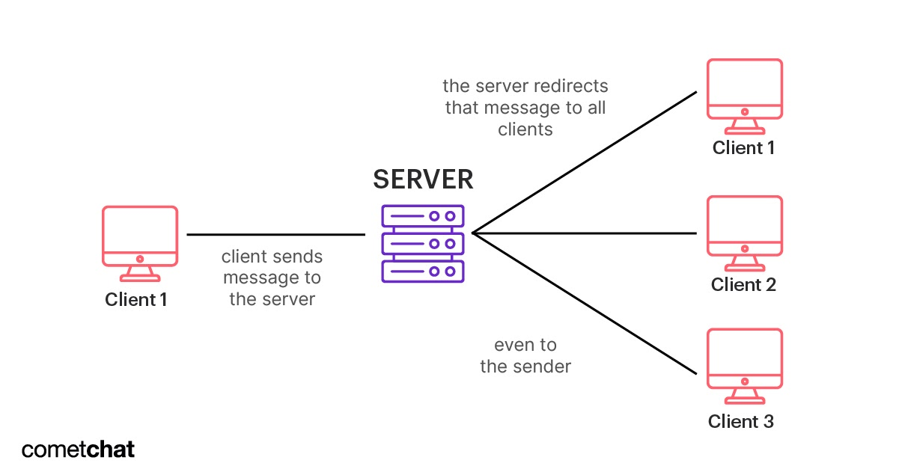

System Architecture

When designing a chatting application, the system architecture plays a crucial role in ensuring efficient communication and scalability. Here is a high-level overview of the typical components and their interactions in a chat application's system architecture:

User Interface (UI):

The UI layer enables users to interact with the application, sending and receiving messages, managing contacts, and configuring settings.

It can be implemented as a web interface, mobile app, or desktop client, depending on the target platform.

Client-Side Components:

Chat Client:

The chat client runs on the user's device and handles the rendering of the UI, user input, and sending/receiving messages to/from the server.

Local Storage: Client-side storage can be used to cache message history, user preferences, and other relevant data for quick access.

Server-Side Components:

Application Server: The application server is responsible for handling user authentication, managing connections, and processing chat-related operations.

WebSockets: A bidirectional communication protocol like WebSockets is often used to establish a persistent connection between the client and server, facilitating real-time message exchange.

API Gateway:

An API gateway can handle client requests, route them to appropriate services, and perform authentication and rate limiting.

Message Broker: A message broker (e.g., RabbitMQ, Apache Kafka) may be used to decouple the chat server from message distribution. It helps with scaling and ensuring message reliability.

Database: To store chat messages, user profiles, and other persistent data, a database system (e.g., SQL, NoSQL) is used. It allows efficient retrieval and storage of chat-related information.

External Services:

Authentication Service: An authentication service (e.g., OAuth, JWT) can be utilized to handle user authentication and authorization.

Push Notification Service:

If the application supports push notifications, an external service (e.g., Firebase Cloud Messaging, Apple Push Notification Service) can be used to deliver notifications to users' devices.

Third-Party Integrations:

Emojis, file sharing, location sharing, and other features may require integration with third-party services or APIs to provide additional functionality.

Scalability and Load Balancing:

To handle a large number of concurrent users, the system architecture should be designed for scalability. This can involve horizontal scaling by adding more servers and using load balancing techniques to distribute incoming traffic evenly.

Monitoring and Analytics:

Monitoring tools and analytics platforms can be employed to track system performance, detect errors, and gather insights about user behavior.

It's important to note that the specific architecture of a chat application can vary depending on factors such as the desired features, expected user base, technology stack, and business requirements.

## 4.2 Data Flow Diagrams

DFD stands for Data Flow Diagram. It is a graphical representation that depicts the flow of data within a system. DFDs consist of three levels: Level 0 DFD provides an overview of the entire system, Level 1 DFD focuses on major processes, and Level 2 DFD provides a detailed view of subprocesses within Level 1. DFDs use symbols such as circles for processes, arrows for data flows, and rectangles for external entities or data stores. By visualizing the flow of data, DFDs help in understanding the system's structure, identifying potential bottlenecks or inefficiencies, and facilitating effective communication between stakeholders during system analysis and design.

## 4.2.1 Data Flow Diagram – Level 0

DFD Level 0, also known as Context Diagram, provides an overview of the entire system by showing the interactions between the system and external entities. It represents the system as a single process and illustrates the inputs, outputs, and data flows between the system and external entities without going into detailed subprocesses or internal processes.

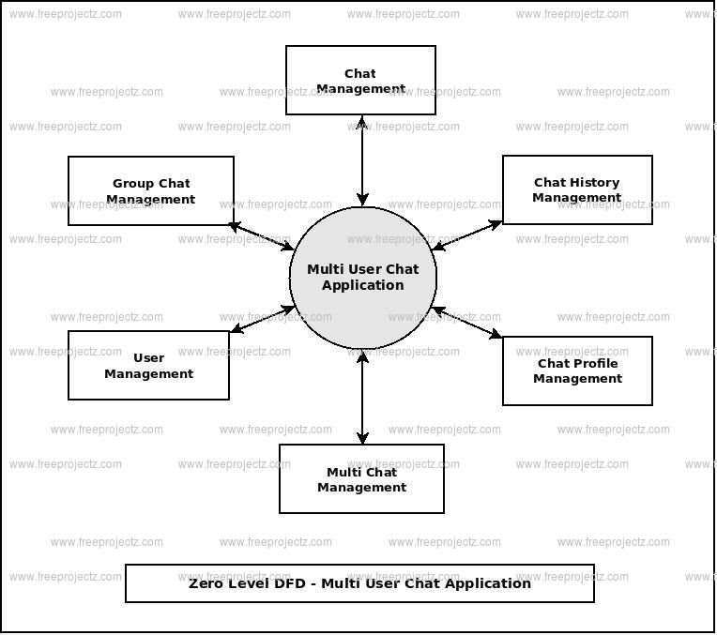

Figure 4.2: DFD – Level 0

## 4.2.2 Data Flow Diagram – Level 1

DFD Level 1 represents a more detailed view of the processes identified in Level 0. It breaks down the major processes into their sub-processes, showing the data flows between them. Level 1 DFD provides a clearer understanding of the system's internal workings, highlighting the interactions and transformations of data within the system.

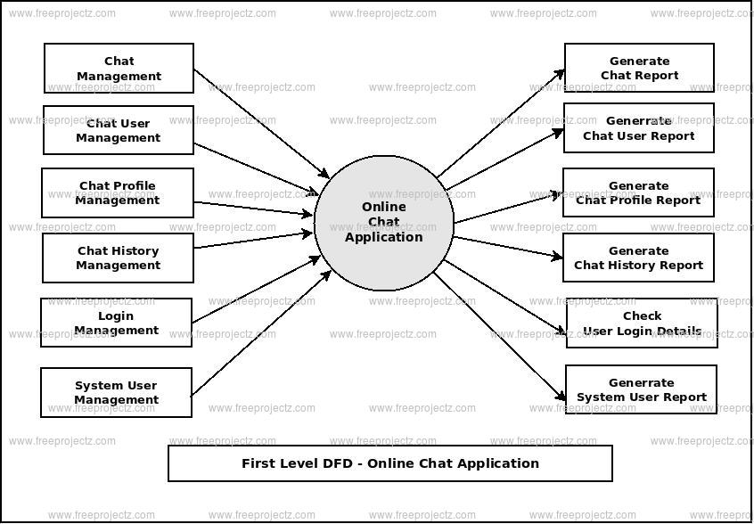

Figure 4.3: DFD – Level 1

The Level 1 DFD provides a more in-depth understanding of the system by integrating the system's processes, such as feature extraction, dataset splitting, classifier construction, etc.

## 4.2.3 Data Flow Diagram – Level 2

In a Data Flow Diagram (DFD), Level 2 represents a more detailed view of the system compared to Level 0 and Level 1. At Level 2, the focus shifts to individual processes and their interactions within each major process identified in Level 1. It provides a more granular depiction of data flow, showing inputs, outputs, and data transformations within each subprocess. Level 2 DFD helps in understanding the specific activities and data flows occurring within each process, enabling a more detailed analysis of system functionality.

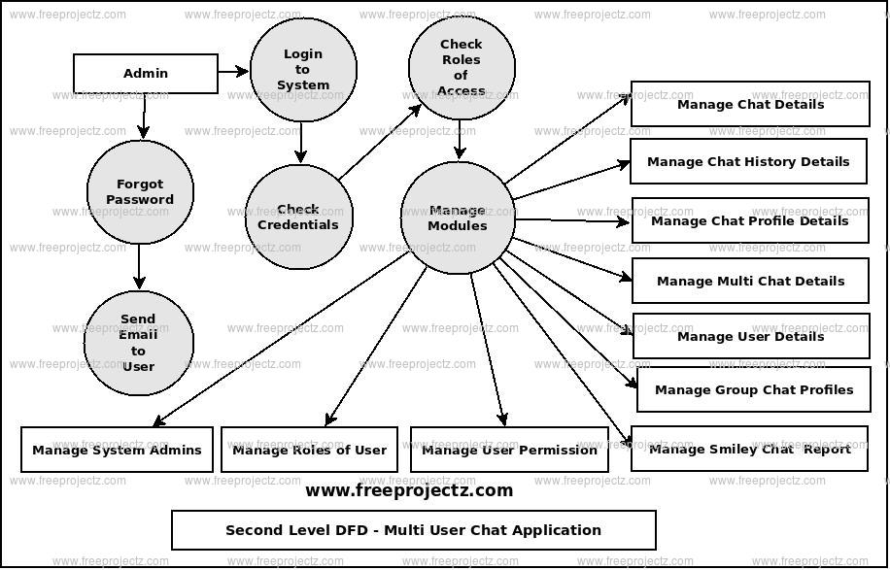

Figure 4.4: DFD – Level 2

## 4.3 UML Activity Diagram

UML Activity Diagram is a graphical representation used to model the flow of activities or processes within a system. It shows the sequence of actions, decisions, and parallel or concurrent flows in a clear and intuitive manner.

It helps in identifying dependencies, defining the order of execution, and visualizing the overall flow of the system.

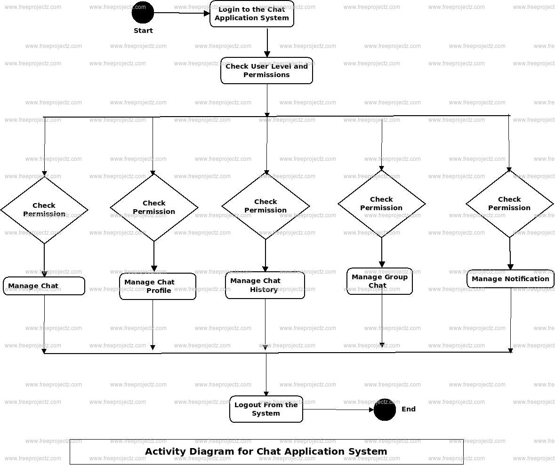

Figure 4.5: UML Activity Diagram

## 4.4 Summary

In the chapter that was just mentioned, was the architecture of the system, the processes that are involved from input to output with an increasing amount of complexity, and the behavior of the system are all visually represented to help readers get a better knowledge of the system.

# CHAPTER 6

# RESULTS AND DISCUSSION

You may create a functioning and interactive messaging system by constructing a chatting application with Java and socket programming, as well as AWT (Abstract Window Toolkit) and Java Swing for the user interface. Here's a high-level overview of the procedure and a breakdown of its essential components:

## Programming Sockets:

## In Java, socket programming allows you to create a network connection between a client and a server.

## To construct the necessary sockets for communication, you may utilise Java's Socket and ServerSocket classes.

## The client-side socket will connect to the server-side socket, allowing messages to be exchanged.

## User Interface (UI):

## The Java packages AWT and Swing are used to create graphical user interfaces (GUIs).

## AWT provides a minimal collection of components, whereas Swing provides a more comprehensive toolkit with more functionality.

## To develop an intuitive chat interface, you may utilise several components such as buttons, text boxes, lists, and panels.

## Architecture of Client-Server:

## A client-server architecture is commonly used for talking applications.

## The server will accept incoming connections and handle many client connections at the same time.

## Clients will connect to the server and interact using the sockets that have been created.

**Protocol for Communication:**

For the client and server to exchange messages, you must specify a communication protocol.

You can, for example, specify that messages be transmitted as strings in a particular format, such as JSON or XML.

On both ends, the protocol should manage message sending, receiving, and any necessary processing.

**Message Processing:**

The server should process incoming client messages and route them to the proper recipients.

To handle messages and ensure they reach their intended recipients, you can use a messaging queue or data structure.

Clients must be able to send and receive messages, as well as refresh the chat window and view the conversation.

**Authentication and security of users:**

You can use user authentication procedures to guarantee safe connection.

To connect to the chat server, users may be required to enter credentials (e.g., username and password).

To safeguard sensitive data transported over the network, encryption mechanisms such as SSL/TLS can be used.

**Handling Errors and Managing Exceptions:**

Handling exceptions and failures that may arise during socket connectivity, UI interactions, or network difficulties is critical.

Implement proper exception handling techniques to handle problems gracefully and to display informative error messages.

**Discussion:**

Building a chatting application with Java, socket programming, and AWT/Swing lays a solid basis for developing an interactive messaging system. The combination of socket programming with user interface libraries enables real-time communication as well as a visually pleasing user interface.

Socket programming makes it easier to create connections and exchange messages between the client and server. It enables dependable and effective network communication.

AWT and Swing give the components and tools required to develop a sophisticated user interface. To improve the user experience, you may create windows, buttons, text fields, and other interactive components.

Using a client-server design allows numerous users to join and interact at the same time, promoting cooperation and discourse. The server may manage message distribution and ensure that all messages are delivered to their designated recipients.

You may improve security by implementing user authentication processes and using encryption techniques for safe communication.

Remember to handle exceptions correctly in order to ensure stability and give a consistent user experience.

Overall, you can create a sophisticated and user-friendly chatting application with real-time messaging features by integrating Java, socket programming, and AWT/Swing.

## Running Project Screenshot

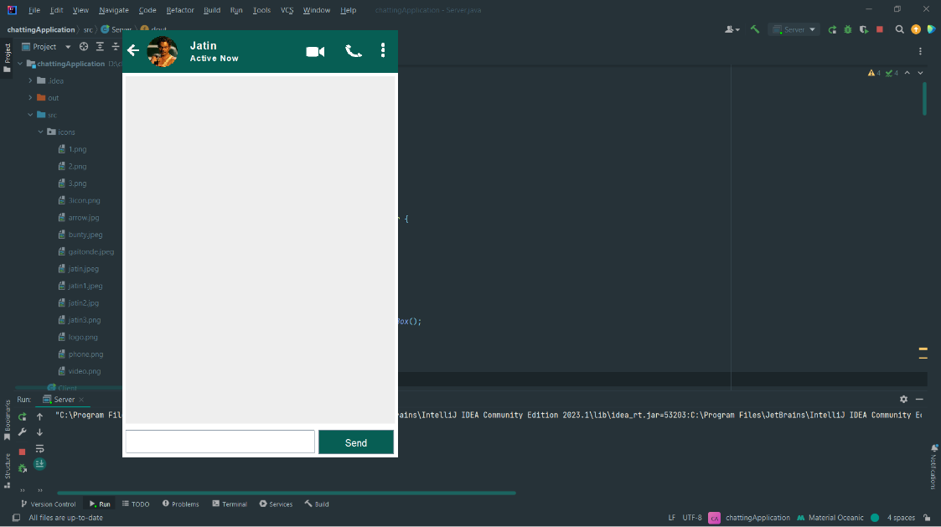

Figure 6.1: Running Screenshot – Server page

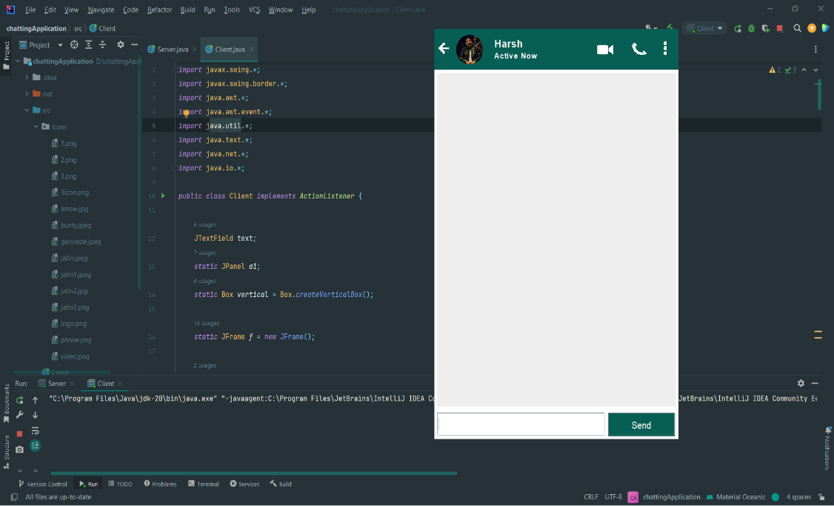

Figure 6.2: Running Screenshot – client page

# CHAPTER 7

# CONCLUSION

## 7.1 Conclusion

Finally, developing a chatting application with Java, socket programming, and AWT/Swing lays a good basis for developing a functioning and interactive messaging system. The following are the main points:

Java socket programming allows for the development of network connections between clients and servers, allowing for real-time communication.

Windows, buttons, text boxes, and panels are just a few of the components and tools available in the AWT and Swing frameworks for creating a user-friendly graphical interface.

Multiple users may join and interact at the same time because to the client-server design, which encourages cooperation and discourse.

Defining a communication protocol guarantees that messages are sent, received, and parsed properly between clients and servers.

Using user authentication systems and encryption techniques improves security and protects sensitive data sent over the network.

By gracefully managing mistakes and showing informative error messages, proper exception handling improves stability and delivers a smooth user experience.

## 7.2 Future Scope

A talking application built with Java socket programming and AWT/Swing has various possibilities for enhancement and extension in the future. Here are some possible future paths:

1. As technology improves, you might look for methods to improve the user interface by adding current design concepts, responsive layouts, and increased usability. To design more aesthetically appealing and engaging interfaces, consider using contemporary UI frameworks such as JavaFX or web-based front-end technologies.
2. With the rising popularity of smartphones and mobile devices, adopting the talking application for mobile platforms might be a potential future approach. To create mobile versions of the application, you can look at frameworks like Java ME or cross-platform frameworks like React Native or Flutter.
3. A talking application designed with Java socket programming and AWT/Swing provides several potential improvement and extension options. Here are some potential future directions:
4. As technology advances, you may seek ways to improve the user interface by incorporating contemporary design principles, responsive layouts, and better usability. Consider adopting modern UI frameworks like as JavaFX or web-based front-end technologies to create more visually beautiful and engaging interfaces.
5. With the increasing popularity of smartphones and mobile devices, implementing a talking application for mobile platforms might be a viable future strategy. You may use frameworks like Java ME or cross-platform frameworks like React Native or Flutter to develop mobile versions of your application.

# References

"Java Socket Programming: Create a Chat Application": This article on Baeldung's website walks you through the process of constructing a small chat application using Java socket programming. It covers the fundamentals of client-server communication and message handling. It may be found at: <https://www.baeldung.com/java-chat-app-with-sockets>

Oracle Java Tutorials: "Creating a Chat Client/Server Solution in Java" Oracle's official Java tutorials give detailed instructions for creating a chat client/server application with Java socket programming. It goes through the fundamentals of sockets, threading, and message exchange. It may be found at: <https://docs.oracle.com/javase/tutorial/networking/sockets/clientServer.html>

"Creating a Chat Client/Server Solution in Java" on Oracle's Java Tutorials: Oracle's official Java tutorials give detailed instructions for creating a chat client/server application using Java socket programming. It covers the fundamentals of sockets, threading, and message exchange. You may find it at: <https://docs.oracle.com/javase/tutorial/networking/sockets/clientServer.html>

Oracle Java Tutorials: "Java Swing Tutorial" This Oracle lesson gives an in-depth overview of Java Swing, covering the fundamentals of designing graphical user interfaces using AWT and Swing components. It contains examples and descriptions of various components and their applications. You may find it at: <https://docs.oracle.com/javase/tutorial/uiswing/>

Kathy Sierra and Bert Bates' "Head First Java": This book takes a laid-back approach to teaching Java programming. It covers key principles such as socket programming and Swing GUI development. To strengthen your comprehension, the book includes clear explanations, examples, and tasks.

"Java Network Programming" by Elliot Rusty Harold: This book digs into network programming using Java, covering topics such as socket programming, multithreading, and communication protocols. It includes real-world examples and insights on designing network applications, which may be applied to the development of a talking application.